ZAP SUMMER! Trial  WHEN: August 10 - 11 2024  WHERE: Argus Ranch/Run Wild  35612 212th Way SE  Auburn, WA 98092  JUDGE:  Jackie Loeser (1 judge, 2 ring trial)  TRIAL FORMAT: Double Run  BUILDING AND RING SURFACE INFO:  90 x 90 rings, inside on turf  CONTACT SURFACE: Rubber pellets  CRATING SET UP TIMES: 7 am Saturday  BRIEFING AT: See Trial Schedule  FIRST DOG ON THE LINE AT: 8 am each day  Pre-Entries Open on: May 10, 2024  Pre-Entries Close on: July 26, 2024 | PRELIMINARY CLASS ORDER:  May change depending on weather, judge’s preference, time or number of entries - See website for tentative run schedule  SATURDAY  Class: Double Run Single Run  Weavers 2  Gamblers 2  Jumpers 2  Regular 2  SUNDAY  Class: Double Run Single Run  Regular 2  Chances 2  Tunnelers 2  Grounders 2

ENTRY LIMITS: Trial is limited to 500 runs total per judge per day.  MOVE UPS: Move-Ups will be allowed at this trial if received no later than 30 minutes after the last class on the previous day. There will be a Move-up sheet at the score table.  PRE-ENTRIES: Entry pricing is PER HOUSEHOLD. All entries must be entered and paid for in one envelope. ADDITIONAL ENTRIES ADDED AFTER WILL BEGIN AT THAT TIME’S PRICING.  DAY OF SHOW ENTRIES: Post-closing and day of show entries will be accepted as space allows.  REFUNDS: There will be no refunds for entries withdrawn after the closing date or in the event a dog and/or handler are dismissed from competition, regardless of the reason for such dismissal, including, but not limited to, aggressive dogs.  Handlers with medical emergencies providing a doctor’s note (on request) or having an injured dog with veterinarian’s documentation, may cancel 7 days prior to the start of the trial and receive a 50% credit slip.  Handlers with a bitch in heat, with veterinarian’s documentation (on request) may cancel after closing and receive a 100% credit slip only.  Due to the rising costs of trial production there will be a $20 processing fee for cash (check) refund before closing though an exhibitor may choose to receive a credit slip for 100% of the refund value for no additional cost.  There is a $25 fee for NSF checks. | SHOW COMMITTEE  Trial Chair: Cathy Horrocks  Trial Secretary: Katrina Tustin  Chief Course Builders: Mike & Nancy Roller  Ring Stewards: Eden Van Ballegooijen & Scooter  Awards: Vicki Hurley  Equipment Manager: Cathy Horrocks  Hospitality: Club members  CONFIRMATIONS: will be emailed only.  FOOD INFO: Due to COVID, ZAP will NOT be serving ANY food or water. Please be prepared to bring all your own nourishment.  VOLUNTEER INFO: We will use the whiteboard system. Please volunteer! This helps the trial run smoothly.  AWARDS AND RIBBONS: Ribbons will be awarded for first thru fourth place in all jump heights of all divisions except for Chances which is a Q/no Q class. Qualifying ribbons will be awarded for qualifying runs.  Please let us know if you may achieve a NATCH so that we have a ribbon for you too.  EQUIPMENT INFO: All equipment is within NADAC standards.  CRATING: Due to COVID, there will be NO CRATING inside for exhibitors. Crating area will be for club members and course builders only.  You may crate and set up tents outside on the hill. Crate pads must be taken up each evening (per Argus) if used.
Jump Height Info:
MEASURING
Measurement forms may be obtained at:
https://www.nadac.com/WPsite/wp-content/uploads/2021/06/Permanent-Height-Card-form-6.4.21.pdf
Dogs which require measuring:
Dogs in the Proficient Category, Novice, Open or Elite jumping 4”, 8”, 12” or 16”

Dogs which do not need to be measured:
Dogs jumping 16” in the Veteran or Junior Handler Division
Dogs jumping 20”
Dogs in the Skilled Category
Dogs with a permanent height card
Dogs listed on the Height Exemption List
JUMP HEIGHTS
There are four Standard Division-Proficient jump heights: 8”, 12”, 16”, and 20”.
There are four Standard Division-Skilled jump heights: 4”, 8”, 12”, and 16”.
There are four jump heights for the Veterans and Junior Handler divisions: 4”, 8”, 12”, and 16”.
Please see the NADAC Rulebook for the full jump height table
Brief Summary of Rules:
Please refer to www.nadac.com for a full explanation of all NADAC rules and up to date information.

- Please note that NADAC trials should provide a safe and fun environment for both exhibitors and their dogs.
- Aggressive dogs will not be tolerated and will be excused from the trial.
- The show committee has the right to refuse any entry. Anyone not currently in good standing with NADAC will not be allowed to enter this trial.
- Exhibitors, through submission of entry, acknowledge that they are knowledgeable of NADAC rules and regulations, and agree to abide by all rules in effect at the time of this trial.
- No entry fee will be refunded if the trial cannot open or be completed by reasons of riots, civil disturbances, fire, acts of God, public emergency, an act of a public enemy, or any other cause beyond the control of the organizing committee.
- Checks not honored by the bank do not constitute a valid entry fee. There will be a $25.00 service charge for bank returned checks.
- Dog must be registered and have a valid registration number before entries will be accepted. https://www.nadac.com/register-your-dog/
- A copy of the current Exhibitors Handbook may be downloaded free from the NADAC web site: www.nadac.com
- Bitches in heat, lame, or blind dogs are ineligible for entry, as is any dog with a deformity which may cause a judge to not be able to reasonably assess the dog’s ability to function and perform agility obstacles safely, and in a manner that is in the best interest, health and welfare of the dog.
- No food, clickers, or other aids or devices shall be permitted on the course or within 10 feet of the ring. Food or a small non-audible toy can be in a secure container (ziplock bag is acceptable) in your pocket during your run but you cannot indicate to the dog it is there. All handlers may bring a non-audible toy into the ring for training purposes. They cannot earn a Qualifying score and must declare to the judge they are training before they commence their run. Please read the Exhibitor’s Handbook for more information about toys and training in the ring.
- The sponsoring clubs will not be responsible for the loss or damage to any dog exhibited, or for the possessions of any exhibitor whether the result be accident or other cause. It is distinctly understood that every dog at this event is in the care and control of his owner or handler during the entire time the dog is on the show premises.

LODGING INFO AND DIRECTIONS:
• All camping, RV and Brutus Hall reservations must go thru Argus Ranch. Visit https://www.argusranch.com/book-a-room

Other lodging options - Please confirm all details when making reservations.
• Kings Value Inn - 360-825-1626 - 1334 Roosevelt Way E Enumclaw; $10 per dog per night under 50lbs
• Best Western Park Central Motel -360-825-4490 - 1000 Griffin St., Enumclaw; $10 per dog per night
• Best Western Park Plaza -253-848-1500 - 620 S Hill Dr., Puyallup; $25 plus tax per stay non-refundable, no dogs left in room or in lobby during breakfast
• Sumner Motor Inn - 253-863-3250 - 15506 E Main, Sumner; $10 per dog per night

Driving Directions to Argus Ranch/Run Wild:
From North/South I-5 or SR-167
- Exit WA-18 East
- Exit Auburn-Black Diamond Road East keep right
- Right at SE Green Valley Rd (just past Neely Mansion)
- Follow Green Valley Rd approximately 7.5 miles
- Right onto 212th Way SE (Christmas tree farm on the left)
- First LEFT into Argus Ranch/ Run Wild driveway Follow signs for parking
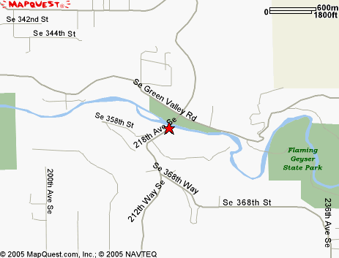

NEW GROUNDERS CLASS!!!

For more information about Grounders and how points & titles will be combined, visit https://www.nadac.com/grounders-info/

Course Design
- Course design is going to consist of Hoopers, Barrels and a very light use of Tunnels. We would like to see a minimal amount of tunnels in the class, but they are a great obstacle to use for keeping the course design interesting, so you should expect to see them on course.
- There will continue to be the option of a 15 point run if the run is completed from behind the extra point line, same as the current Hoopers class.
- The hoop circle will continue to be a staple in the class, but it will be modified quite a bit, as other obstacles will be able to substitute for the hoops. Such as a barrel or tunnel.
- Standard Course time will start out fairly lenient, until we have a years worth of dogs runs to base the SCT off of real world data, and then it will get updated to reflect the dogs currently competing.
- All normal NADAC rules will apply.
- A course design examples is posted below
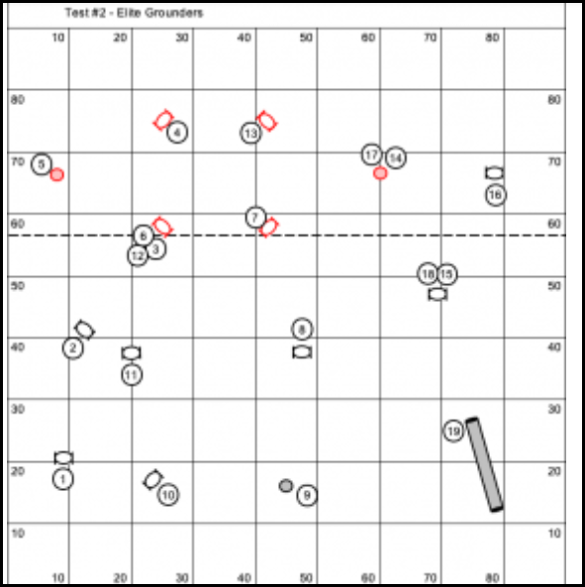
ZAP SUMMER! Trial, August 10 - 11 2024 at Argus Ranch/Run Wild in Auburn WA
Send entries & make checks payable to: ZAP/Cathy Horrocks 31412 49th PL SW, Federal Way, WA 98023
* Please note that Katrina has to come over to collect all entries so there will be a delay in receiving your confirmation!

Owner Name: |  |  |  |  |  | Dog’s Call Name:
Address: |  |  |  |  |  | NADAC Reg #:
City/State/Zip: |  |  |  |  |  | Date of Birth: |  | Sex: M F
Phone: |  |  |  |  |  | Height at Withers: | Breed:
Email: |  |  |  |  |  | I WANT MY DOG TO JUMP: 4 8 12 16 20
Handler, If not owner: |  |  |  |  |  | Emergency Contact Name/Phone:
PLEASE INCLUDE A COPY OF YOUR DOG’S HEIGHT CARD IF YOU DO NOT HAVE ONE ON FILE.
CAT.: PROFICIENT SKILLED |  |  |  |  | DIV.: STD VET DOG VET HAND. JR HAND.
Class | Level |  |  |  |  | Day
 | Intro | Novice | Open | Elite |  | Saturday | Sunday
Regular |  |  |  |  |  | Rd 1 Rd 2 | Rd 1 Rd 2
Chances |  |  |  |  |  | Not Offered | Rd 1 Rd 2
Jumpers |  |  |  |  |  | Rd 1 Rd 2 | Not Offered
Touch n Go | NA | NA | NA | NA |  | Not Offered | Not Offered
Tunnelers | NA |  |  |  |  | Not Offered | Rd 1 Rd 2
Weavers | NA |  |  |  |  | Rd 1 Rd 2 | Not Offered
Gamblers | NA |  |  |  |  | Rd 1 Rd 2 | Not Offered
Grounders | NA |  |  |  |  | Not Offered | Rd 1 Rd 2
In consideration of the acceptance of this entry, I/we certify that I/we have knowledge of, and are familiar with, and agree to abide by, the Rules and Regulations of NADAC in effect at the time of this trial, and by any additional rules and regulations as approved by NADAC for this trial. I/we certify that the dog entered is not a hazard to persons or other dogs. I/we further agree to be bound by the “Agreement” printed on page 5 of this premium. The person who signs this agreement represents that he/she is authorized to enter into this agreement on
behalf of both exhibitor and the owner of entered dog. In consideration of acceptance of this entry:
1.1. As used here "NADAC" means the North American Dog Agility Council, LLC., its members, officers, directors, employees, show chairs, show committees and agents.
1.2. Exhibitor/owner agree to abide by the rules and regulations of NADAC and any other rules and regulations appearing in the premium for this event.
1.3. Exhibitor/owner certify that the entered dog is not a hazard to persons, dogs or property and that the entered dog's rabies vaccination is current in accordance with the requirement of the state in which the dog resides.
1.4. Exhibitor/owner acknowledge all hazards presented by the event and the event premises, including, but not limited to, the condition of the surface, restrooms, security measures or lack of, electrical appliances, fittings, show rings, parking areas and the presence of unfamiliar animals and people; exhibitor and owner assume the risk of any harm arising from these.
1.5. Exhibitor/owner releases NADAC (including its respective officers, directors, employees, and members), ZAP (including its officers, directors, members, and event organizing committee), and ARGUS RANCH (including its officers, agents, and employees) and will defend them and hold them harmless from all present and future loss, injury, damage, claims, demands and liabilities involving the entered dog, the event or event premises. Without limiting the generality of the foregoing, hold harmless provisions, exhibitor/owner hereby specifically assumes sole responsibility for and agrees to indemnify and save the aforementioned parties harmless from any and all loss and expenses (including legal fees) by reason of the liability imposed by law upon any of the aforementioned parties for damages because of bodily injuries, including death, at any time in consequence of my (our) participation in this event, howsoever such injury or death may be caused and whether or not the same may have been caused or may have been alleged to have been caused by negligence of the aforementioned parties or any of their employees or agents or any other persons

Owner/Exhibitor: ____________________________________Date______________________

Parent/Legal Guardian of Jr Handler________________________________
PRE ENTRY PRICING: | □ JR. HANDLERS 50% OFF (Pre-entry Only) | TOTAL ENCLOSED
□ 1 - 6 Runs = $14 each =
□ 7 - 13 Runs = $13 each = | AFTER CLOSING PRICING:
□ 14 + Runs = $12 each = | □ Post Closing (July 27th – Aug 7th) = $16 each =
 | □ Day of Show (Aug 8th – Aug 11th) = $17 each =

